From the classes of errors listed Below, Design C program fragment to Compare the outputs of Splint and the Standard C compiler.

1. Dereferencing a possibly null pointer

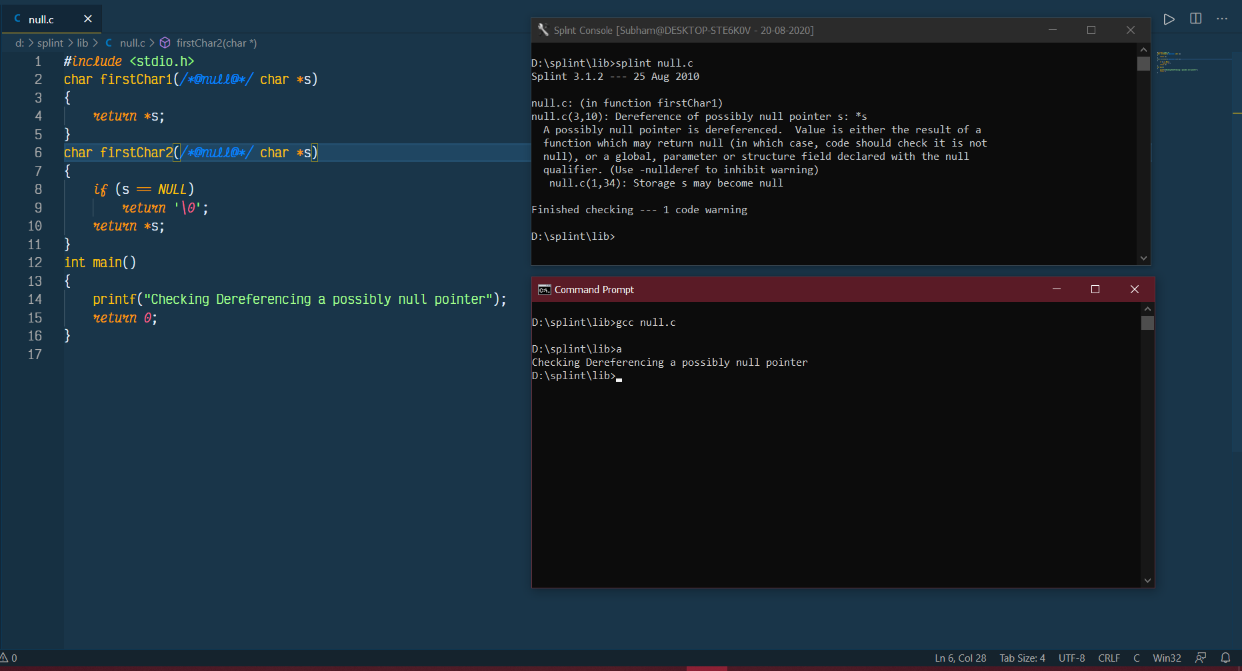

1. Using possibly undefined storage or returning storage that is not properly defined

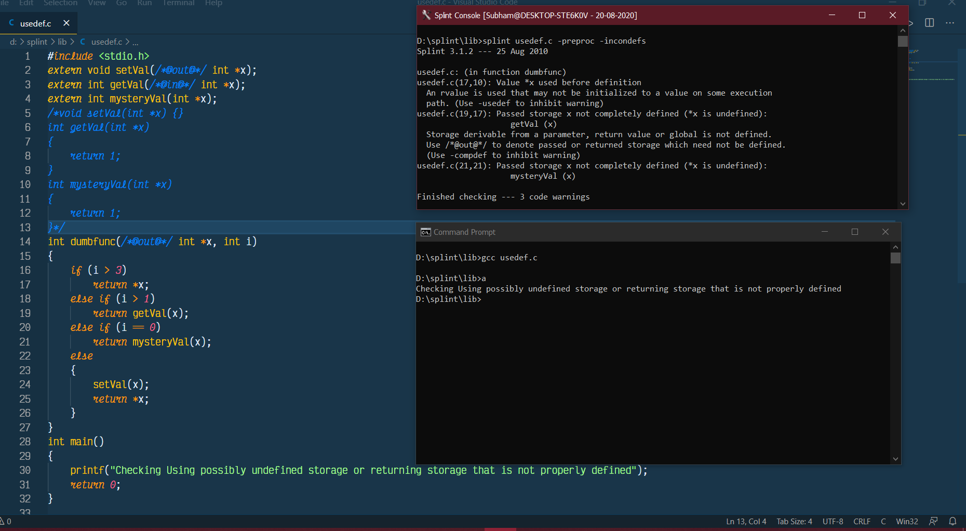

1. Type mismatches, with greater precision and flexibility than provided by C compilers

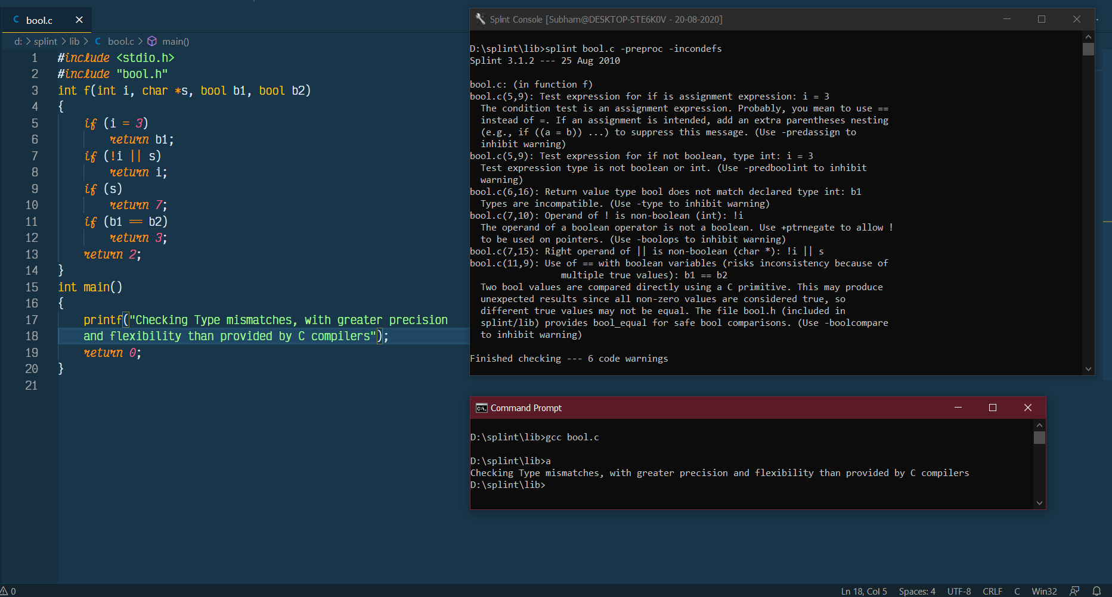

1. Violations of information hiding

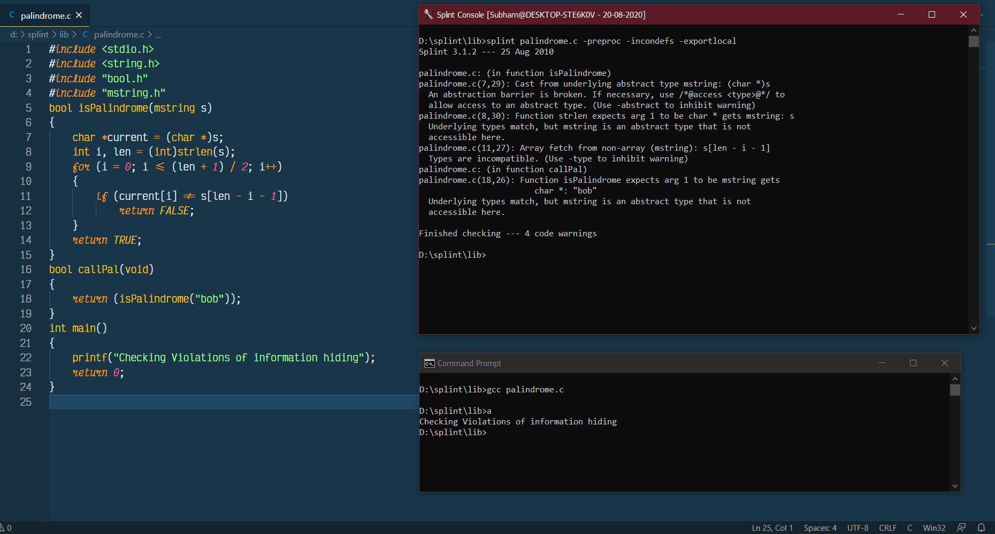

1. Memory management errors including uses of dangling references and memory leaks

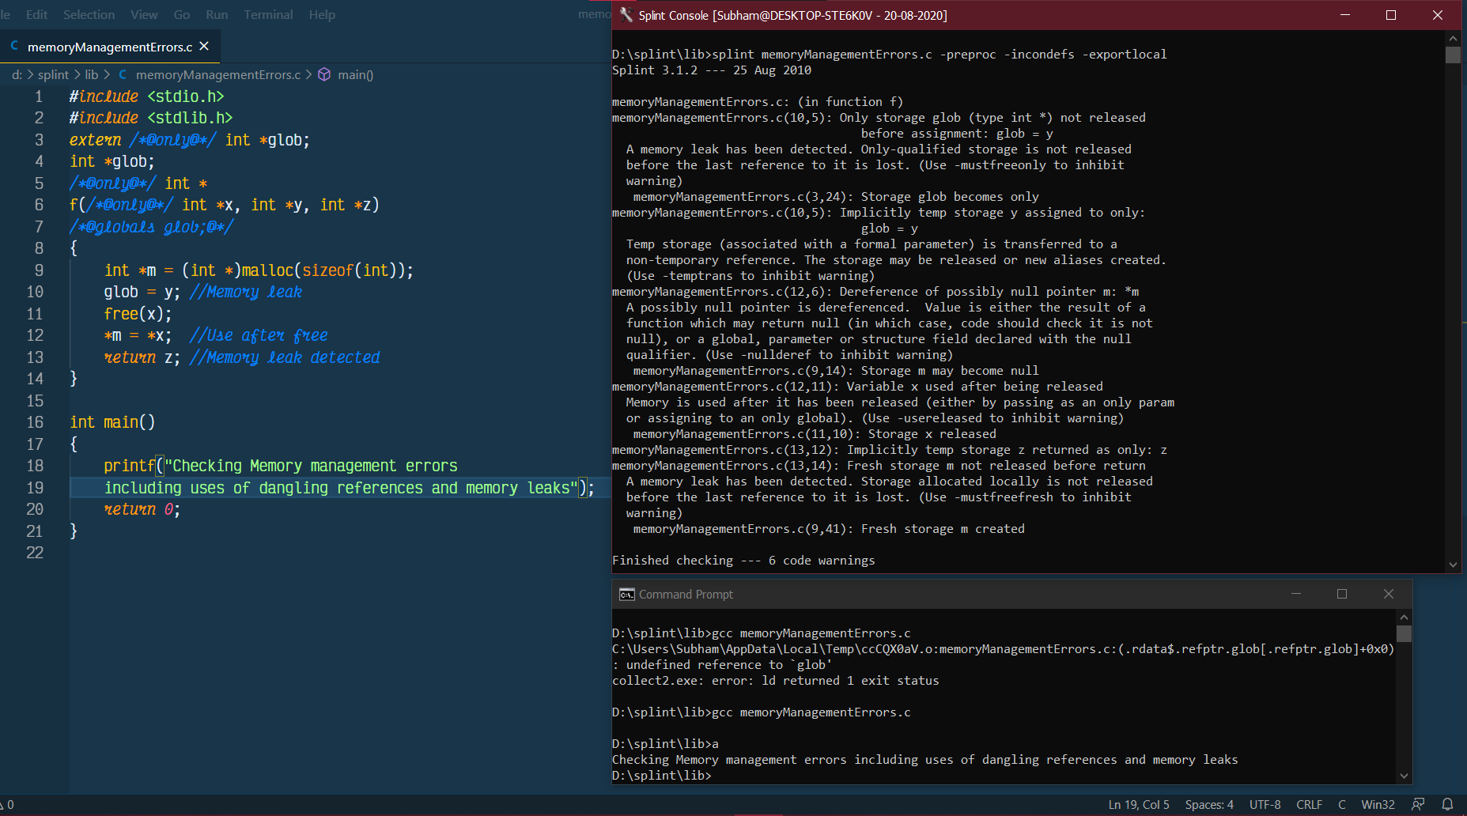

1. Dangerous aliasing

